TestRail – Day 6: Test Plans & Milestone Management
Date: 29-Jan-2026
Learning Objective
• To understand Test Plans in TestRail
• To learn about Milestones, Versioning, and Scheduling
• To create and manage a Test Plan
• To execute multiple test runs under a single plan
1. Test Plan in TestRail
Definition:
• A Test Plan is a container that groups multiple test runs together to manage testing for different versions, environments, or cycles of a project.
Learning Points:
• Used for large or structured testing efforts
• Helps manage multiple test runs in one place
• Provides centralized tracking of progress
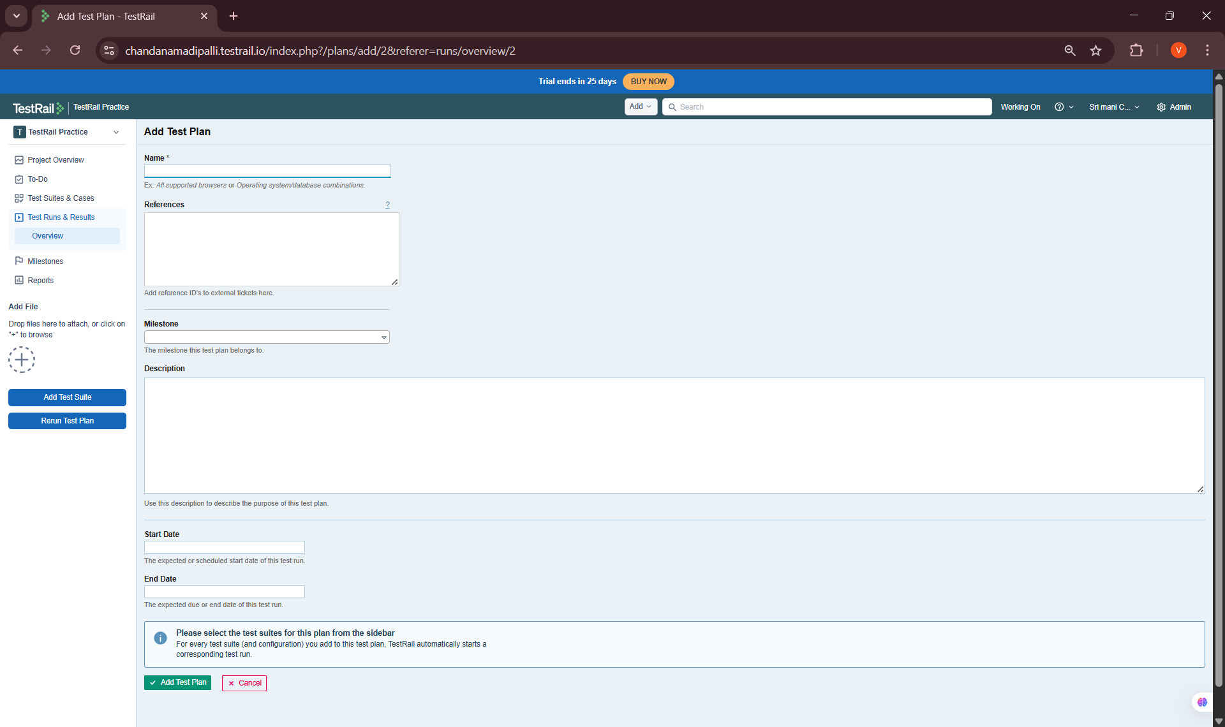
2. Milestones
Definition:
• A Milestone represents a major phase or version of the project (e.g., Release 1.0, Sprint 2).
Learning Points:
• Helps track testing progress per release
• Used for reporting and planning
• Can be linked to test plans and test runs
Examples Used:
• Version 1.0
• Sprint Release – January
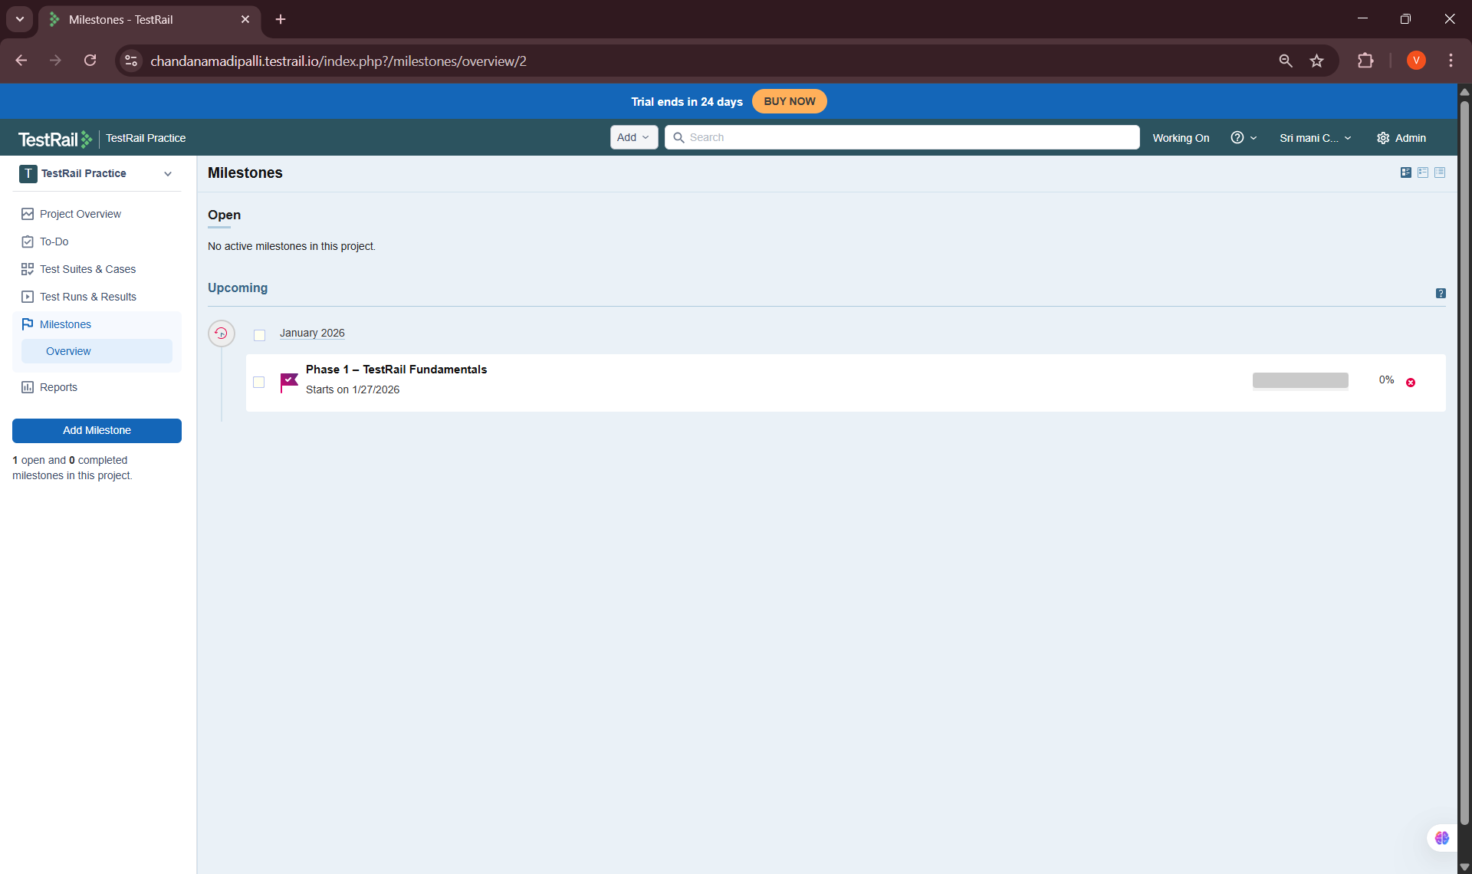
3. Versioning in Test Plans
Definition:
• Versioning allows testers to manage test execution for different versions of the application within a single test plan.
Learning Points:
• Same test cases reused across versions
• Separate test runs created for each version
• Helps compare quality between releases

4. Scheduling Test Plans
Definition:
• Scheduling allows testers to define start and end dates for test execution.
Learning Points:
• Helps plan testing timelines
• Improves release predictability
• Useful for tracking delays
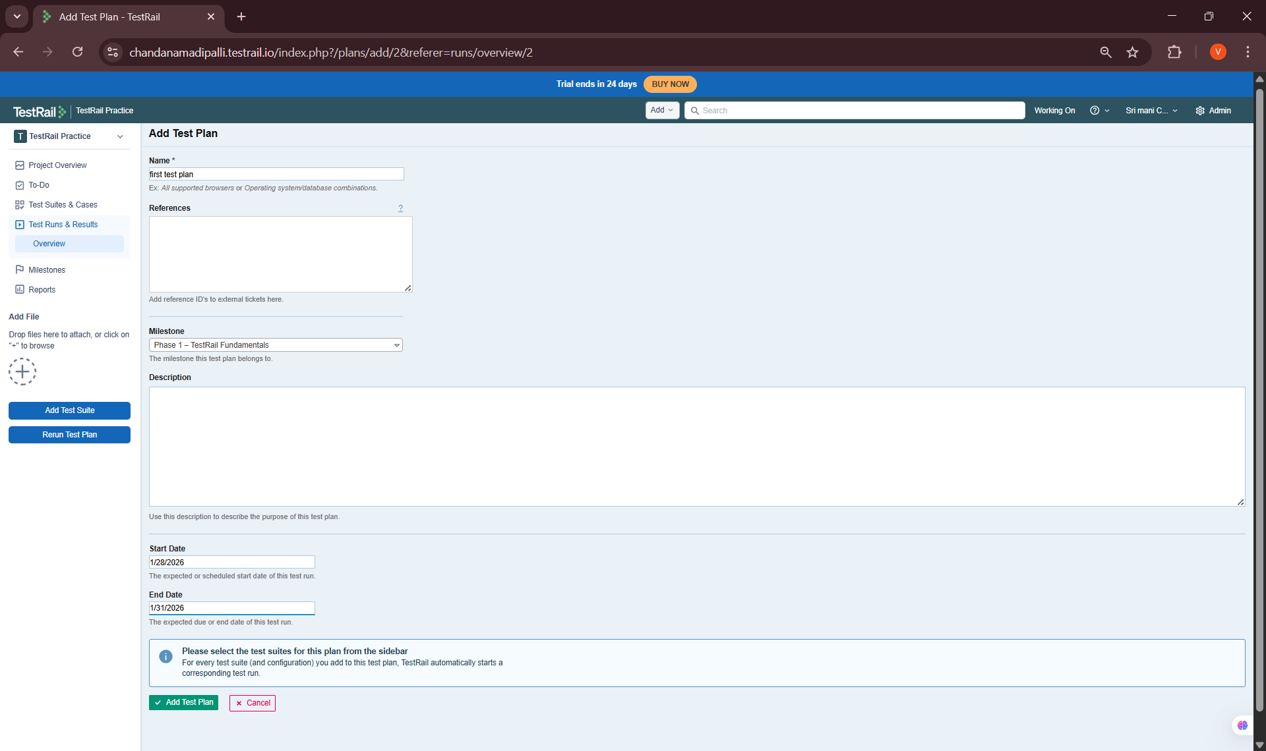

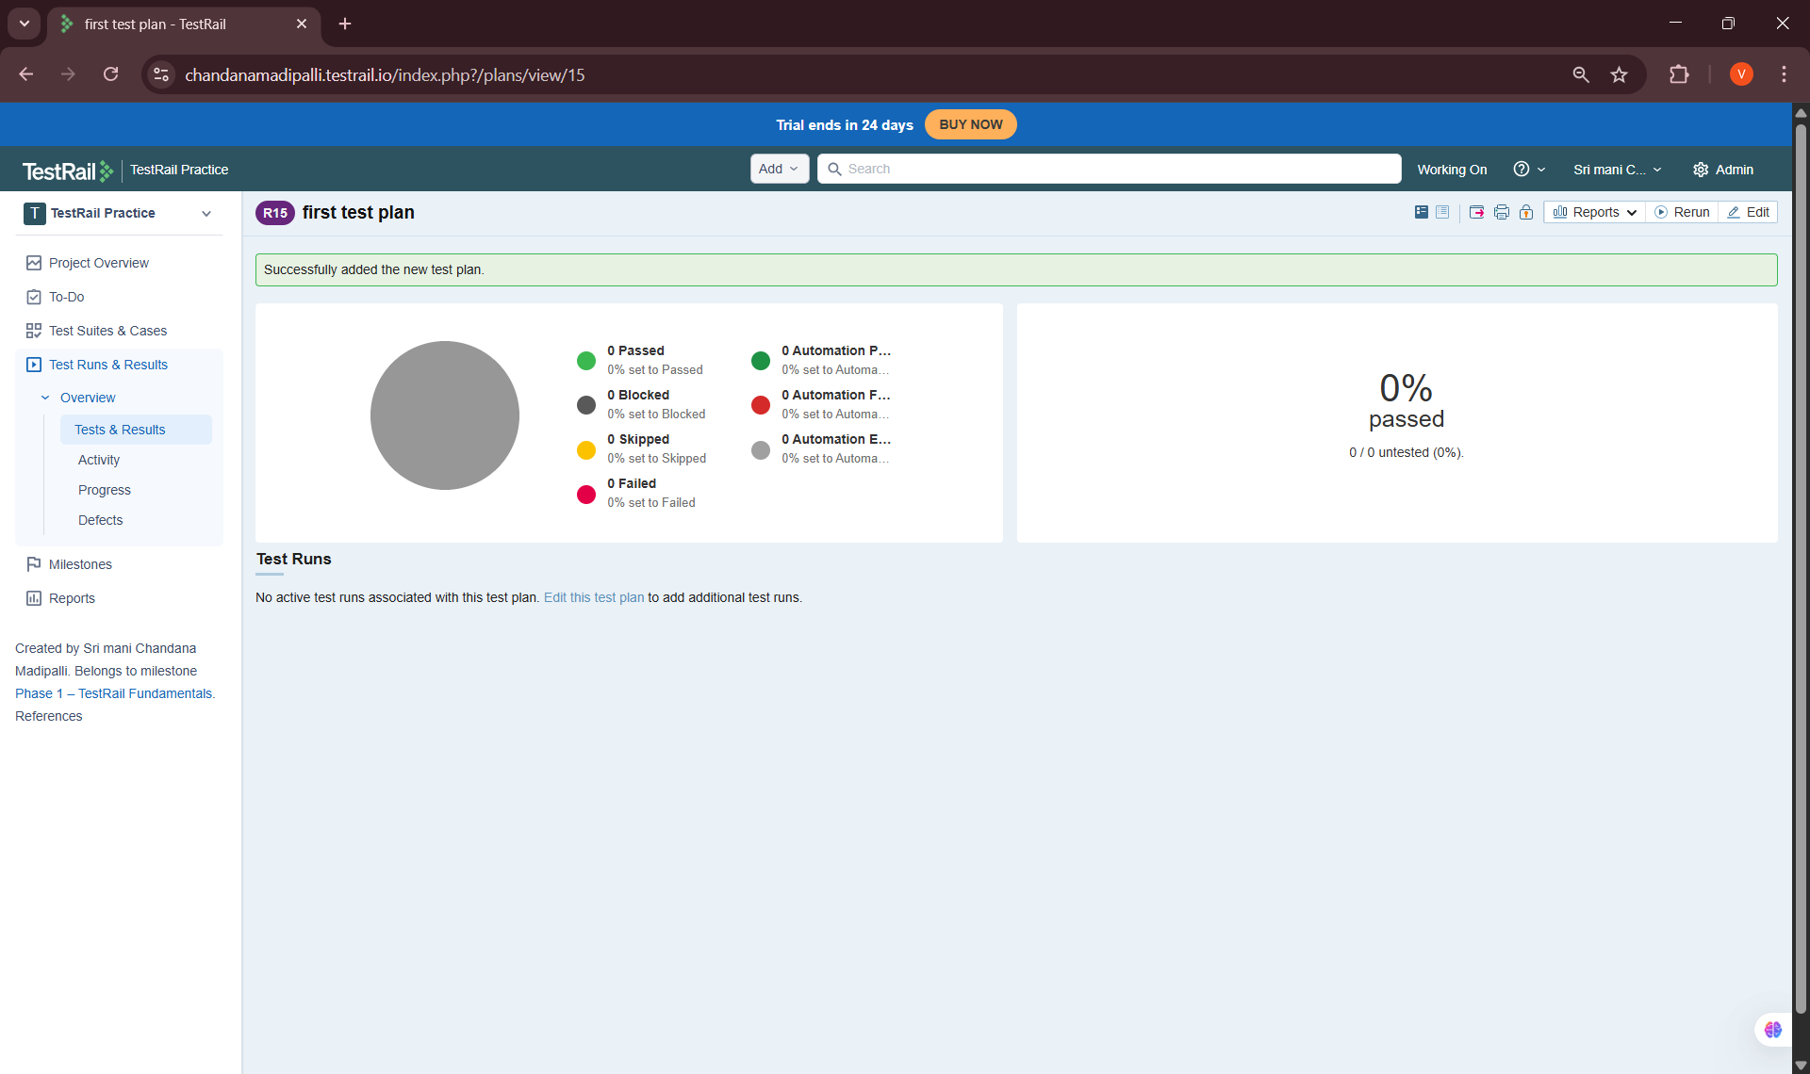
5. Creating a Test Plan (Hands-On Task)
Steps Performed:
• Navigated to Test Plans & Runs
• Clicked Add Test Plan
• Entered test plan name
• Linked the plan to a milestone
• Added multiple test runs
• Assigned testers
• Defined execution schedule
📸 Screenshots to add:
• Add Test Plan screen
• Adding test runs to plan
• Final created test plan overview
Key Learnings & Outcomes
• Understood the purpose of test plans
• Learned how milestones support release tracking
• Gained knowledge of version-wise testing
• Successfully created a structured test plan
• Managed multiple test runs under one plan

